LAB 1

Objective: To study and simulate the behavior of an analog computer using differential equation. (Any five)

Theory
The simulation of an analog computer is based on three main concepts:
- Mathematical Modeling: Any physical system can be represented by a differential equation. In an analog computer, voltage is used as the "analog" for the variables in those equations.

- Operational Blocks: The system uses three primary operations:
  - Integration: Using Op-Amp integrators to convert derivatives (like acceleration) into variables (like velocity and displacement).
  - Summing: Combining different terms of the equation.
  - Scaling (Gain): Multiplying variables by constants (the coefficients in your equations).

- Feedback Loops: By connecting the output of the integrators back to the input summer, the circuit "forces" itself to follow the mathematical rules defined by the differential equation.

Procedure
- Rearrange the given differential equation to isolate the highest derivative term.
- Determine the number of Integrators required based on the order of the equation (1 for first-order, 2 for second-order).
- Set up the Summing Junction to add the input signals (forcing functions like sin(t) or constants) and the feedback signals.
- Assign Gains (coefficients) to the feedback loops using Potentiometers or Gain blocks.
- Run the simulation and observe the behavior of y(t) on an oscilloscope or Time-Scope.

Experiment:

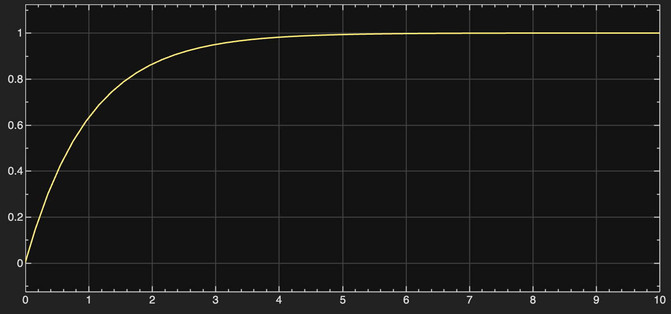

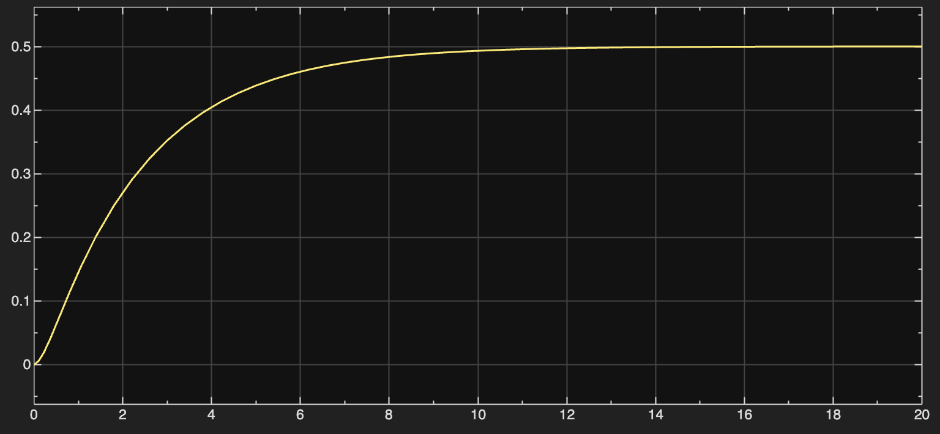

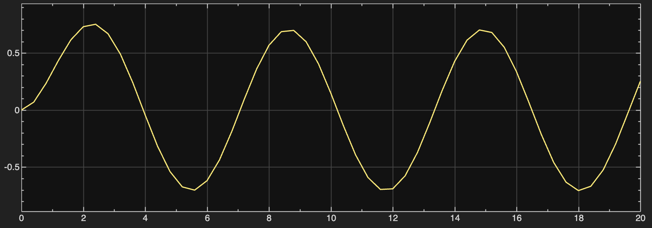

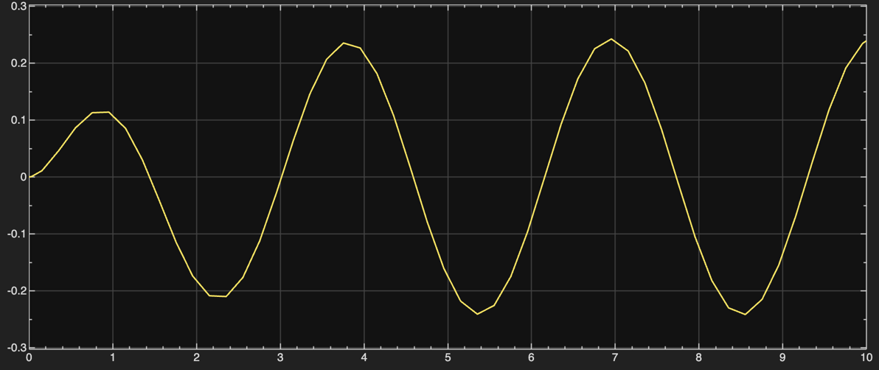

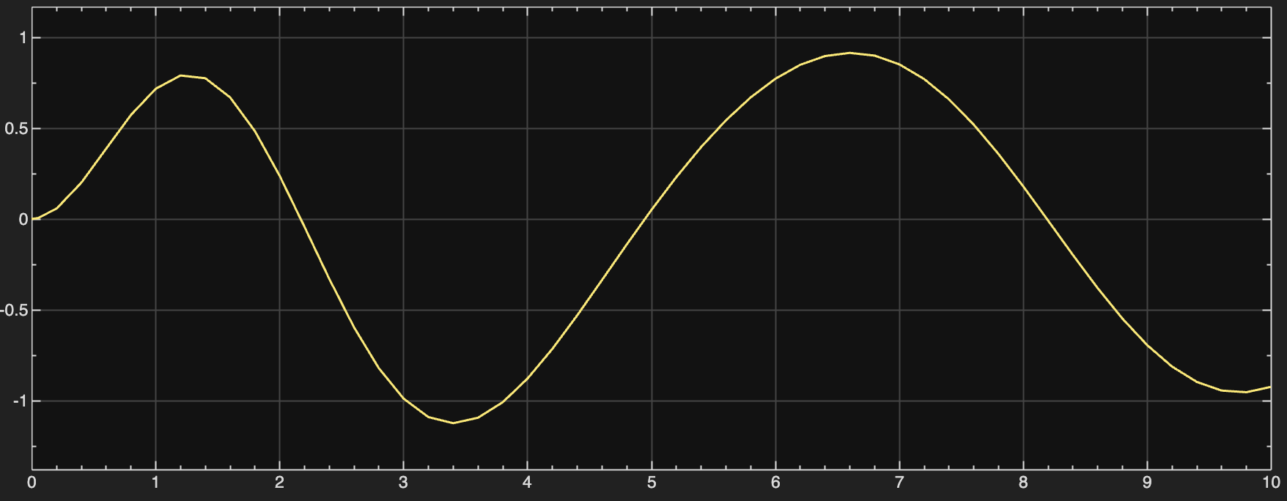

Result
The differential equations were successfully modeled. For 1st order systems, y(t) followed an exponential path. For 2nd order systems, the presence of the dy/dt term acted as "damping," while the forcing functions (sin, cos) dictated the long-term behavior.

Conclusion
Analog simulation provides a continuous-time solution to differential equations. By using integrators and feedback loops, complex physical systems (represented by these equations) can be simulated in real-time.

